1. **Agenda**:
   1. We will summarize everything we have learnt so far before writing a lot of code and before using JMS 2.0.
2. 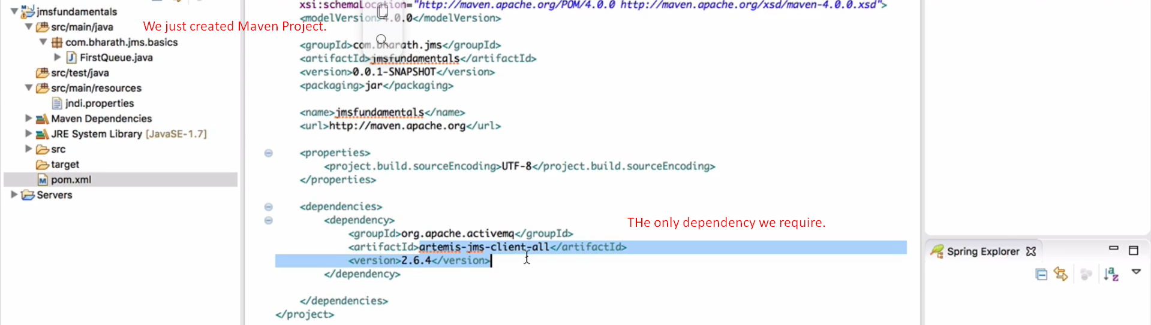
3. Then we created a jndi.properties file where we initialized the JNDI initial connection factory info which will create context for JNDI working as entry point for JNDI.
4. 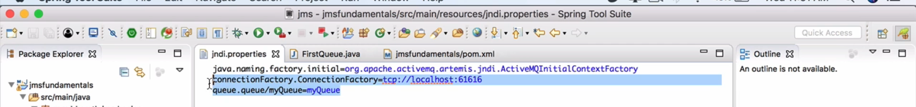  
     
   **NOT CLEAR**.